Opening Prayer by astronaut Frank Borman
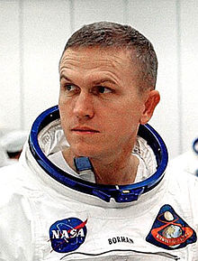
The following prayer was broadcast to Earth on Christmas Eve 1968 by astronaut Frank Borman while on a moon-orbiting mission aboard Apollo 8: “Give us, O God, the vision which can see thy love in the world in spite of human failure. Give us the faith to trust thy goodness in spite of our ignorance and weakness. Give us the knowledge that we may continue to pray with understanding hearts. And show us what each one of us can do to set forward the coming of the day of universal peace. Amen.”
Source: The Philmont Cub Scout Roundtable Supplements March 2018 Cubs of the future - A Scout is Loyal.pdf

